|  |
| --- |
| Circle Language Spec: Execution Control |

## Exit Loop in a Diagram

The concept of Exit Loop was explained the article *Exit Loop*. The current article only explains its expression in a diagram.

The Exit Loop command is displayed inside the clause that is looped as a jump to the Command End of the whole loop.

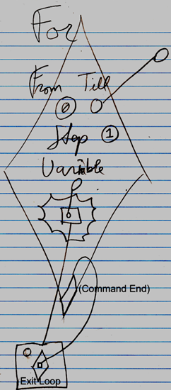

The text Command End is not required in the diagram:

